SIMATS ENGINEERING (SAVEETHA SCHOOL OF ENGINEERING)
Department of Computer Science and Engineering
CO3 ASSESSMENT TOOL 2 – Code Review & Repository Evaluation

Course Code: | CSA10 / CSA1063 | Course Title: | Software Engineering
CO Assessed: | CO3 | Assessment: | Assessment Tool 1 – Code Review & Repository Evaluation
Weightage: | 20% | Total Marks: | 25
CO3 Statement: | Build full-stack applications with an emphasis on containerization, version control, and collaborative development
Student Name: |  | Reg. No.:
Date: |  | Duration: | 60 minutes

Code of Conduct
I _________H.Ganesh Kumar(192572027)_________________ (Name / Reg No) certify that this submission is my original work and that I have adhered to the guidelines specified for this assessment. I understand that any violation of academic integrity rules will result in disciplinary action.
Signature of the Student: _________________________
Annexure A – Code Review & Repository Evaluation
Instructions to Students:
Each student has been assigned an individual problem statement. Based on the assigned problem statement, perform a Code Review and Repository Evaluation of your project. Analyze the quality of the source code, repository organization, documentation, coding practices, and overall maintainability. Provide appropriate screenshots, code snippets, diagrams, and justifications wherever applicable.

Assignment Questions
- Problem Overview
  - Explain the assigned problem statement and summarize the implemented solution.
  - Describe the project objectives and key functionalities.
- Repository Organization
  - Evaluate the repository structure, folder organization, and file naming conventions.
  - Justify how the repository layout supports maintainability and collaboration.
- Code Quality Review
  - Review the source code for readability, modularity, coding standards, and documentation.
  - Identify strengths and areas for improvement.
- Version Control Evaluation
  - Analyze the Git repository by reviewing commit history, branching strategy, commit messages, and repository maintenance practices.
  - Explain how version control supports collaborative software development.
- Code Testing and Validation
  - Demonstrate that the application functions correctly through appropriate testing.
  - Present test cases, execution results, and screenshots as evidence.
- Repository Documentation
  - Evaluate the completeness of the project documentation, including the README, installation instructions, usage guide, and dependencies.
  - Suggest improvements to enhance usability and maintainability.
- Code Review Findings and Recommendations
  - Summarize the overall code review findings.
  - Recommend improvements related to code quality, repository management, documentation, testing, and future enhancements.

Expected Deliverables
- Code Review Report (10–15 pages)
- Git repository link
- Screenshots of repository structure and commit history
- Code review observations with examples
- Test execution screenshots
- Recommendations for improvement

Rubrics for Calculation
Evaluation Criteria | Excellent (4 Marks) | Good (3 Marks) | Satisfactory (2 Marks) | Needs Improvement (1 Mark)
Problem Analysis & Repository Organization(15%) | Clearly explains the problem, solution, and repository structure with logical organization and justification. | Good explanation with minor omissions. | Basic explanation and repository organization. | Incomplete or poorly organized repository.
Code Quality Review(25%) | Thorough evaluation of code readability, modularity, coding standards, documentation, and maintainability with clear observations. | Good code review with minor gaps. | Basic review with limited analysis. | Superficial or inaccurate code review.
Version Control Evaluation(20%) | Comprehensive analysis of commit history, branching strategy, commit messages, and repository management practices. | Good evaluation with adequate explanation. | Basic evaluation with limited evidence. | Poor or incomplete version control analysis.
Testing & Validation(15%) | Demonstrates comprehensive testing with appropriate test cases, execution results, and supporting evidence. | Good testing with minor omissions. | Basic testing with limited evidence. | Inadequate or missing testing and validation.
Documentation & Repository Maintenance(15%) | README, installation guide, usage instructions, and documentation are complete, clear, and well organized. | Documentation is mostly complete. | Basic documentation with missing details. | Poor or insufficient documentation.
Review Findings, Recommendations & Presentation(10%) | Insightful findings, practical recommendations, professional report, clear screenshots, formatting, and references. | Good recommendations and presentation. | Basic recommendations with acceptable presentation. | Weak conclusions and poor presentation.

Criteria | Mark
System Requirement Analysis (30%) | /5
Selection of Software Architecture (25%) | /5
Architecture Diagram and Component Design (20%) | /5
Component Interaction and Quality Attribute Analysis (15%) | /5
Architectural Justification and Technical Presentation (10%) | /5
TOTAL | /25

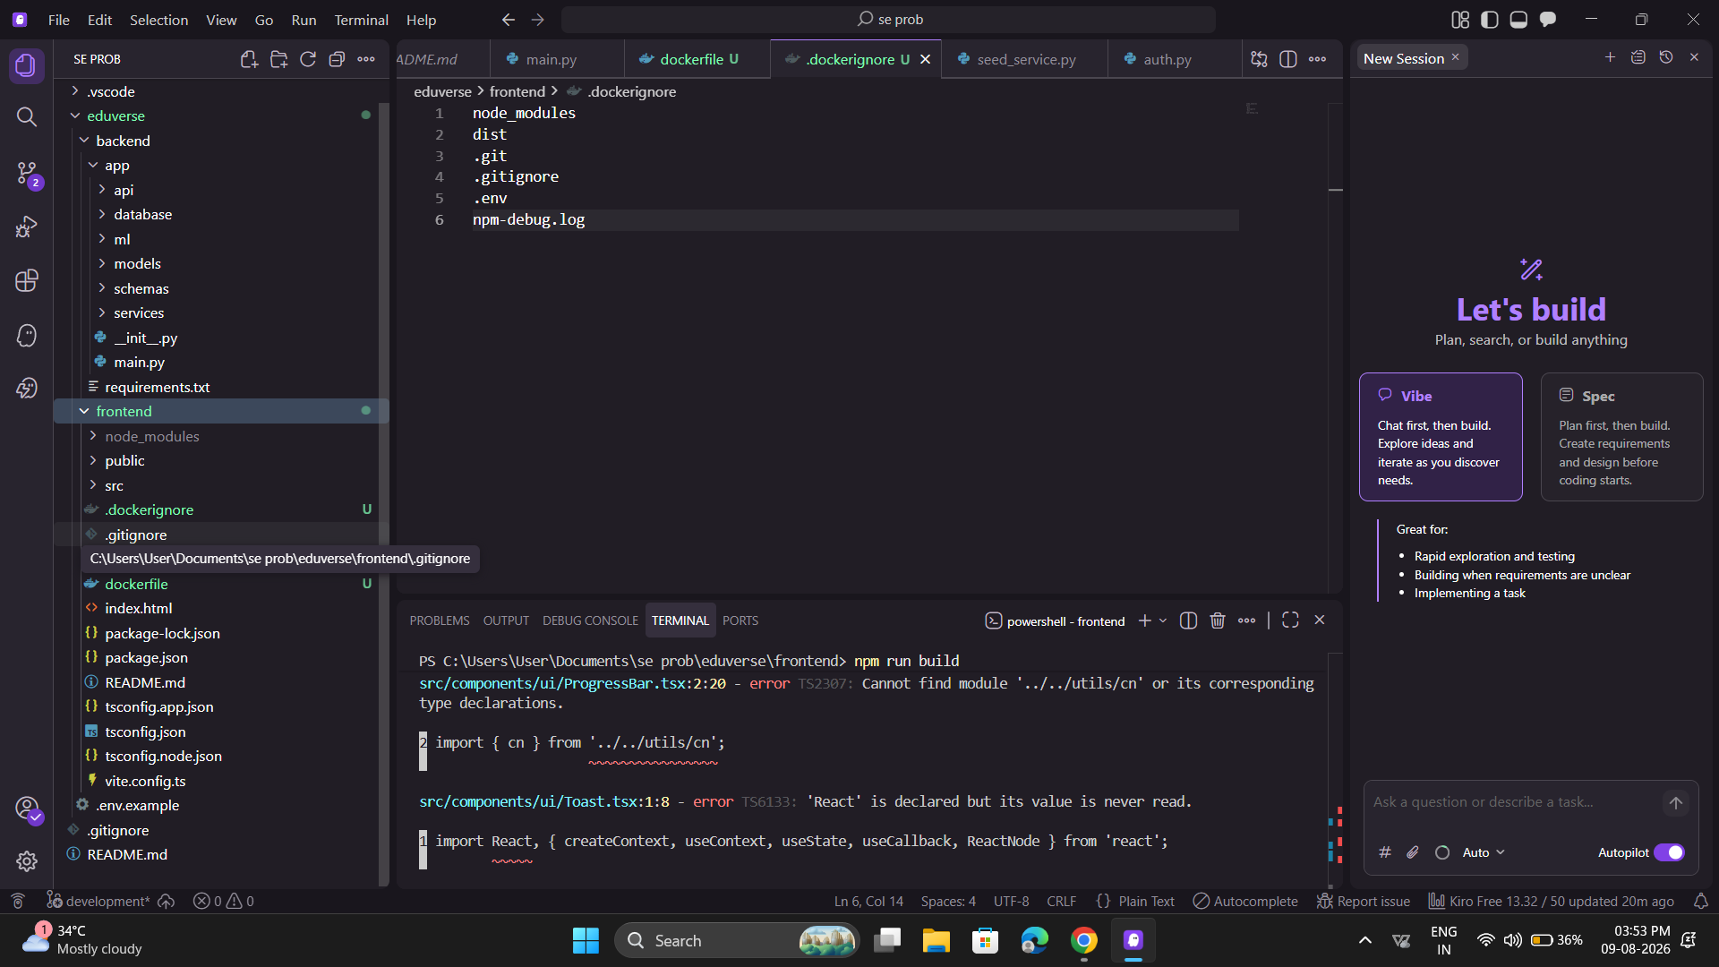

https://github.com/ganesh8667291198-jpg/EduVerse github link

1. Problem Overview

1.1 Problem Statement
EduVerse is an AI-powered adaptive learning and student success analytics platform developed to address the limitations of traditional one-size-fits-all educational systems.
Traditional learning platforms generally provide the same learning content and assessments to all students. However, students differ in their learning abilities, academic performance, learning pace, and engagement levels. Because of this, students who experience learning difficulties may not be identified early.
EduVerse addresses this problem by analyzing student learning behavior, assessment performance, engagement, and academic progress. The system uses these insights to provide personalized learning recommendations, identify learning gaps, support individualized learning plans, and provide academic performance insights.
The platform also provides educators with analytics that can help them monitor student performance and identify students who may require additional academic support.

1.2 Implemented Solution
The implemented EduVerse solution provides a web-based platform through which students can access learning features and educators can monitor student performance.
The major functionality of the platform includes:
- User authentication and access control.
- Student dashboard.
- Learning content access.
- Assessment and quiz functionality.
- Student progress tracking.
- Personalized learning recommendations.
- Student performance analysis.
- Educator analytics.
- Identification of students requiring academic attention.
- AI-assisted adaptive learning capabilities.
The system follows a modular application structure in which the user interface communicates with application services and data sources to provide the required functionality.

1.3 Project Objectives
The primary objectives are:
- Provide personalized learning experiences.
- Analyze student academic and engagement data.
- Identify learning gaps.
- Recommend suitable learning resources.
- Support personalized study planning.
- Provide performance analytics to educators.
- Identify academically at-risk students.
- Improve student engagement.
- Support data-driven academic decisions.

1.4 Key Functionalities

Authentication
The system provides authentication functionality to ensure that users can securely access the appropriate features of the platform.

Student Dashboard
Students can view relevant academic information through a centralized dashboard.

Learning Management
Students can access learning resources and educational content through the platform.

Assessment
The application supports assessments through which student performance can be measured.

Progress Tracking
Student progress can be monitored based on learning activities and assessment outcomes.

Adaptive Recommendations
The system can use student performance and learning information to provide personalized learning recommendations.

Analytics
Performance information can be presented through analytics interfaces to support monitoring and decision-making.

At-Risk Identification
The platform is designed to identify students whose academic or engagement patterns indicate that they may require additional support.

2. Code Quality Review

2.1 Readability
The source code should be evaluated based on whether another developer can understand it without requiring extensive explanation.
Positive characteristics to identify include:
- Meaningful component names.
- Descriptive function names.
- Logical separation of UI components.
- Consistent formatting.
- Clear variable names.
- Appropriate use of TypeScript types.
For example, a component named:
StudentDashboard

is more understandable than a generic name such as:
Component1

Similarly, descriptive functions such as:
fetchStudentProgress()

make the purpose of the function clear.

2.2 Modularity
The application should be divided into reusable components instead of placing all functionality into a single large file.
For example:
Authentication
│
├── Login
├── Registration
└── Authentication Context

Dashboard
│
├── Sidebar
├── TopBar
└── Content

Learning
│
├── Courses
├── Assessments
└── Progress

This approach makes individual modules easier to understand, test, modify, and reuse.

2.3 Coding Standards
The project should follow consistent coding practices such as:
- Consistent indentation.
- Consistent naming conventions.
- TypeScript type definitions.
- Separation of concerns.
- Reusable components.
- Avoidance of unnecessary duplication.
- Proper error handling.
- Removal of unused imports and variables.

2.4 Documentation Within Code
Important functions and complex sections should contain appropriate comments or documentation.
Comments should explain why a particular implementation is required rather than simply repeating what the code does.
For example:
// Calculate progress based on completed learning activities
const progress = calculateLearningProgress(completed, total);

is more useful than:
// Calculate progress

2.5 Strengths
The code review can identify the following strengths in the EduVerse implementation:
- Component-based frontend organization.
- Use of TypeScript for improved type safety.
- Separation of UI elements into reusable components.
- Clear separation between pages, layouts, and reusable UI components.
- Use of modern frontend development tools.
- Application functionality is divided into logical modules.
- The project can be prepared for containerized deployment using Docker.

2.6 Areas for Improvement
The implementation should be reviewed for:

Unused Imports
During the Docker build, TypeScript reported unused imports such as:
'React' is declared but its value is never read.
'Search' is declared but its value is never read.
'Users' is declared but its value is never read.
'Award' is declared but its value is never read.

These should be removed when they are not required.

Missing Module References
The build also reported missing modules such as:
Cannot find module '../../contexts/AuthContext'
Cannot find module '../../utils/cn'

These should be checked to ensure that:
- The required files exist.
- Import paths are correct.
- File-name capitalization is correct.
- Required files are included in the repository.

TypeScript Import Practices
The build also reported:
ReactNode is a type and must be imported using a type-only import

The import should follow the TypeScript configuration, for example:
import type { ReactNode } from "react";

where appropriate.

Build Validation
The application should successfully execute:
npm run build

before it is considered ready for Docker deployment.

3. Code Testing and Validation

3.1 Testing Objective
Testing is performed to verify that the EduVerse application behaves according to its intended functionality and that major user interactions work correctly.
The testing process should verify:
- Authentication.
- Navigation.
- Dashboard functionality.
- Learning content.
- Assessments.
- Progress tracking.
- Recommendations.
- Analytics.
- API communication.
- Application build.

3.2 Functional Test Cases
Test ID | Test Case | Expected Result | Status
TC01 | Open EduVerse application | Landing page loads successfully | Pass/Fail
TC02 | User login with valid credentials | User is authenticated and redirected to dashboard | Pass/Fail
TC03 | Invalid login credentials | Appropriate error message is displayed | Pass/Fail
TC04 | Open student dashboard | Student dashboard loads correctly | Pass/Fail
TC05 | Navigate between modules | Correct page is displayed | Pass/Fail
TC06 | Access learning resources | Required content loads successfully | Pass/Fail
TC07 | Submit assessment | Assessment result is generated | Pass/Fail
TC08 | View progress | Student progress is displayed correctly | Pass/Fail
TC09 | Generate recommendation | Personalized recommendation is displayed | Pass/Fail
TC10 | Open educator analytics | Analytics dashboard loads correctly | Pass/Fail
TC11 | Application build | npm run build completes without errors | Pass/Fail
TC12 | Docker deployment | Application runs successfully inside container | Pass/Fail
Important: Replace Pass/Fail with the actual result obtained during your testing. Do not claim a test passed unless you have executed it.

3.3 Build Validation
The frontend can be validated using:
npm install
npm run build

A successful result indicates that the application can be compiled for production.
In the current implementation, the Docker build revealed TypeScript issues involving unused imports and missing modules. These issues should be resolved before recording the final build as successful.

3.4 Docker Validation
After resolving application build errors, the Docker image can be tested using:
docker build -t eduverse-app .

Then:
docker run -p 5173:5173 eduverse-app

The application can then be accessed through:
http://localhost:5173

The following should be verified:
- Container starts successfully.
- Application loads in the browser.
- Navigation works.
- API communication works.
- Main features operate correctly.

3.5 Testing Evidence
The report should include screenshots such as:
Screenshot 1: EduVerse landing page
Screenshot 2: Successful login
Screenshot 3: Student dashboard
Screenshot 4: Learning/assessment functionality
Screenshot 5: Progress or analytics dashboard
Screenshot 6: Successful npm run build
Screenshot 7: Docker container running
Screenshot 8: EduVerse running from Docker

4. Repository Documentation

4.1 README Evaluation
The README should provide sufficient information for another developer to understand and run the project.
A good EduVerse README should contain:
- Project title.
- Project description.
- Problem statement.
- Key features.
- Technology stack.
- System requirements.
- Installation instructions.
- Environment configuration.
- Application startup instructions.
- Docker instructions.
- Testing instructions.
- Project screenshots.
- Future improvements.

4.2 Installation Instructions
The documentation should explain the required setup.
For example:
git clone <repository-url>
cd EduVerse
npm install
npm run dev

If the application contains separate services, the README should explain how each service is started.

4.3 Dependencies
The project dependencies should be documented through the appropriate dependency files.
For a frontend application:
package.json
package-lock.json

These files identify the required Node.js packages and their versions.
For a Python-based service:
requirements.txt

should identify the required Python dependencies.

4.4 Usage Guide
The README should explain the typical user workflow:
Login
↓
Dashboard
↓
Access Learning Content
↓
Complete Assessment
↓
View Performance
↓
Receive Recommendation
↓
Track Progress

For educators:
Login
↓
Educator Dashboard
↓
View Student Performance
↓
Analyze Engagement
↓
Identify At-Risk Students
↓
Provide Intervention

4.5 Documentation Improvements
The documentation can be improved by adding:
- Clear installation prerequisites.
- Environment-variable documentation.
- Docker setup instructions.
- API documentation.
- Screenshots of major features.
- Troubleshooting section.
- Test instructions.
- Architecture diagram.
- Contribution guidelines.
- Known issues.
- Version information.

5. Code Review Findings and Recommendations

5.1 Overall Findings
The EduVerse project provides a suitable foundation for an adaptive learning and student analytics platform. The application uses a modular frontend structure and incorporates modern development practices such as component-based development and TypeScript.
However, the code review and build validation identified areas that require improvement before the application can be considered fully production-ready.
The most significant issues identified during the current implementation include:
- Unused imports.
- Missing module references.
- TypeScript import-type issues.
- Need for successful production-build validation.
- Need for comprehensive automated testing.
- Need for complete developer documentation.

5.2 Recommendations

Recommendation 1 — Resolve Build Errors
All TypeScript compilation errors should be resolved before deployment.
Priority should be given to:
AuthContext
cn utility
Unused imports
ReactNode type import

Recommendation 2 — Introduce Automated Testing
Automated tests should be added for important components and application functionality.
Testing can include:
- Unit testing.
- Component testing.
- API testing.
- Integration testing.
- End-to-end testing.

Recommendation 3 — Improve Error Handling
The application should provide meaningful error messages when:
- Authentication fails.
- API requests fail.
- Data cannot be loaded.
- Assessments cannot be submitted.
- AI recommendations are unavailable.

Recommendation 4 — Improve Documentation
The README should contain complete installation, configuration, usage, testing, and Docker instructions so that another developer can reproduce the application.

Recommendation 5 — Apply Code Quality Tools
Automated tools such as ESLint and Prettier can be used to maintain consistent coding standards.
For example:
Source Code
↓
ESLint
↓
Detect Code Issues
↓
Prettier
↓
Consistent Formatting

Recommendation 6 — Add CI Validation
A future CI pipeline should automatically execute:
Git Push
↓
Install Dependencies
↓
Lint
↓
Run Tests
↓
Build Application
↓
Build Docker Image

This ensures that broken code is detected before deployment.

Recommendation 7 — Improve Security
Future versions should:
- Keep credentials outside source code.
- Use environment variables/secrets.
- Validate user input.
- Implement proper authentication and authorization.
- Secure API endpoints.
- Avoid exposing sensitive student information.

Recommendation 8 — Improve AI Explainability
Since EduVerse uses AI-based recommendations and performance predictions, future versions should provide explanations for recommendations where possible.
For example:
Student Performance
↓
Learning Gap Detected
↓
Recommendation Generated
↓
Reason for Recommendation
↓
Student/Educator

This can improve trust in the platform.

5.3 Final Assessment
Overall, EduVerse demonstrates a strong foundation for an AI-powered adaptive learning platform. Its modular application design supports further development, while the planned testing, documentation, and deployment practices can improve maintainability.
The current code review indicates that the project should prioritize resolving compilation errors, strengthening automated testing, improving documentation, and introducing continuous code-quality validation. These improvements will make the application more reliable, maintainable, and suitable for future deployment.

